PROJECT DESIGN PHASE-I

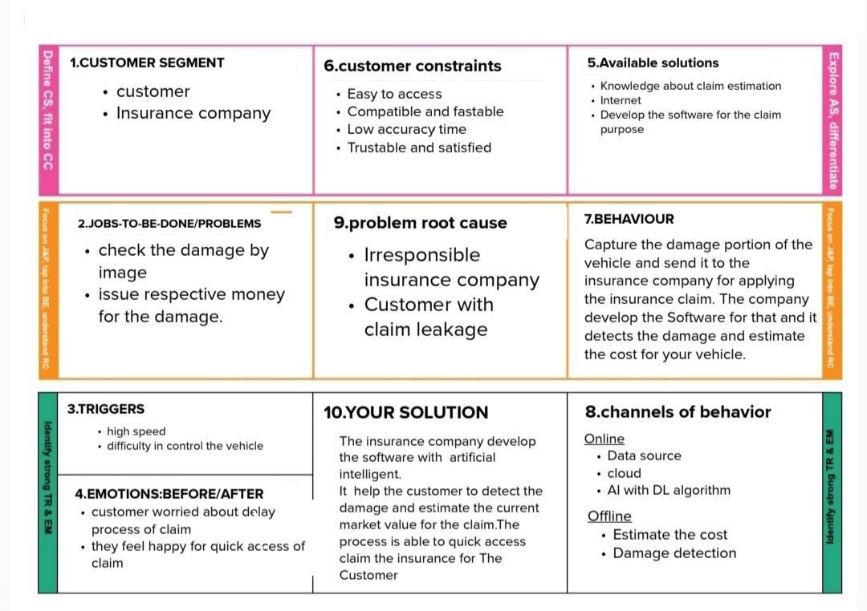

TEAM ID : PNT2022TMID44667

PROPOSED SOLUTION FIT

|  |  |
| --- | --- |
| DATE | 30 October 2022 |
| TEAM ID | PNT2022TMID44667 |
| PROJECT NAME | Project – Intelligent Vehicle Damage Assessment and Cost Estimator For Insurance Companies |
| MAXIMUM MARKS | 2 Marks |

PROPOSED SOLUTION FIT: